**Exercises:**

1. Write a JavaScript to display system date in DD/MM/YYYY format and Dayname, Monthname DD,YYYY  format.

**Source:**

<html>

<head>

</head>

<body>

<script>

function dat()

{

var d=new Date();

var weekday = new Array(7);

weekday[0] =  "Sunday";

weekday[1] = "Monday";

weekday[2] = "Tuesday";

weekday[3] = "Wednesday";

weekday[4] = "Thursday";

weekday[5] = "Friday";

weekday[6] = "Saturday";

var monthname=["Jan","Feb","Mar","Apr","May","Jun","Jul","Aug","Sept","Oct","Nov","Dec"];

var m=monthname[d.getMonth()];

var n = weekday[d.getDay()];

alert(d.getDate()+" / "+d.getMonth()+" / "+d.getFullYear()+" "+n+" "+m+" "+d.getDate()+" "+d.getFullYear());

}

</script>

<input type="button" onclick="dat()" value="get date">

</body>

</html>

**Output:**

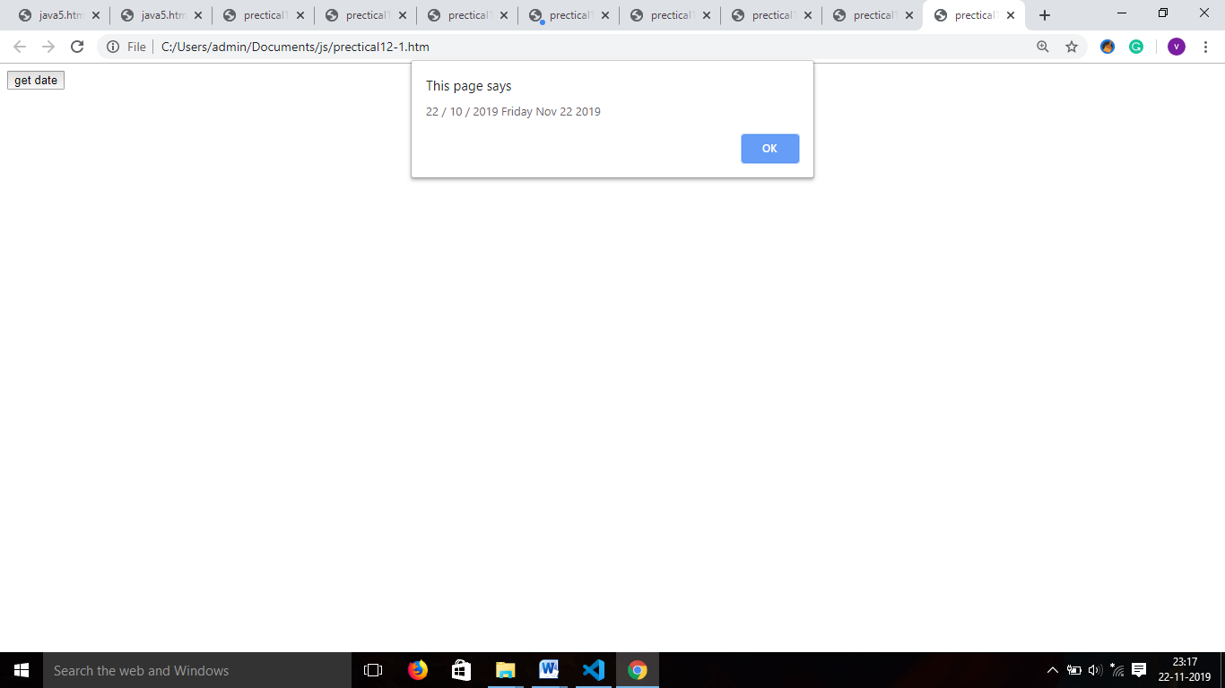

2.      Write a JavaScript to display appropriate message according to system time with A.M. and P.M. Notation.

**Source:**

<html>

<head>

</head>

<body>

<script>

Function dat()

{

var d=new time();

if(d.getHours()>12)

{

var n=d.getHours()-12;

var str=n+":"+d.getMinutes()+":"+d.getSeconds();

document.getElementById('d').innerHTML=str+" PM";

}

else

{

var str=d.getHours()+":"+d.getMinutes()+":"+d.getSeconds();

document.getElementById('d').innerHTML=str+" AM";

}

}

</script>

<input type="button" onclick="time()" value="get time">

<p id="d"></p>

</body>

</html>

**Output:**

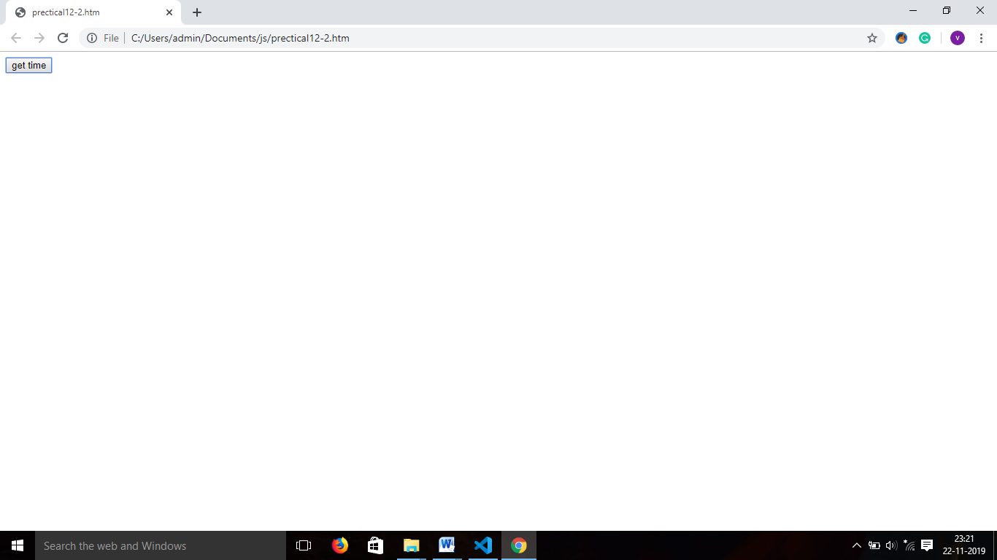

3.      Write a JavaScript to find binary, octal and hexadecimal number of given decimal number.

<html>

<head>

<script>

 no =function(){

var a = document.getElementById('num1').value;

a=parseInt(a);

x=a.toString(2);

y=a.toString(8);

z=a.toString(16);

document.getElementById('d').innerHTML= "binary: "+x;

document.getElementById('e').innerHTML="octal: "+y;

document.getElementById('f').innerHTML="hexa: "+z;

}

</script>

</head>

<body>

<form>

enter no1: <input type="number" name="num1" id="num1">

<input type="button" value="to convert" onclick="no()">

</form>

<p id='d'> </p>

<p id='e'> </p>

<p id='f'> </p>

</body>

</html>

**Output:**

